Suggested Segments when Planning Abbreviated Sessions on the Using Teacher Evaluation Data to Inform Professional Learning Module (June 2014)

The Using Teacher Evaluation Data to Inform Professional Learning Module is a comprehensive module intended for use with personnel at the local level. Outlined here are suggested segments for planning sessions with this module as it may need to be adapted for use in various contexts depending upon 1) the audience, 2) the time of year in the evaluation cycle, and 3) time allocation.

Audience: Administrators/Central Office
Agenda Item(s) | Time | Slides | Activities | Materials
-Welcome, Introductions, and Agenda  -Using Evaluation Data for Self- Assessment and Goal Setting  -Using Evaluation Data for Formative Feedback  -Using Final Summative Evaluation Data for Individual and School wide Planning | 1-1.5 hours | 1,14,19-28, 30, 34-41, 43-45, 47-50 | Activity 4: Strategic Use of Data (briefly)  Activity 5: Strengthening a Self-Assessment (abbreviated to 5 min)  Activity 8: Using Data to Plan for Differentiated Professional Learning (substantial focus)  Activity 9: Using Data to Plan for School wide Professional Learning (substantial focus)  Activity 10: Promising Examples  Activity 11: Pause for Self-Assessment  Activity 12: Action Plan | Handout 2  Handout 4  Handout 5  Handout 6  Handout 7 (district teams)  Handout 8

Audience: Teachers
Agenda Item(s) | Time | Slides | Activities | Materials
-Welcome, Introductions, and Agenda  -Using Evaluation Data for Self- Assessment and Goal Setting  - Using Final Summative Evaluation Data for Individual Planning | 1-1.5 hours | 1,10, 12, 13-16, 20-23, 30, 34-36, 38, 43-45,47-50 | Activity 1: Human Continuum  Activity 2&3: Table Warm-Up Activity 4: Strategic Use  Activity 5: Strengthening Self-Assessment  Activity 8: Using Data to Plan for Differentiated Professional Learning (substantial focus) | Handout 1  Handout 4

Audience: Administrators/Central Office
Agenda Item(s) | Time | Slides | Activities | Materials
-Welcome, Introductions, and Agenda  -Definitions and Assumptions  -Using Evaluation Data for Self-Assessment and Goal Setting  -Using Evaluation Data for Formative Feedback  -Using Final Summative Evaluation Data for Individual and School wide Planning  -Identifying Essential Conditions for Professional Learning | 3-3.5 hours | 1,6,10-19, 21-28, 30, 33-41,44-45,47-50 | Activity 1: Human Continuum  Activity 2: Table Warm-Up  Activity 3: Table Warm-Up Revisited  Activity 4: Strategic Use of Data  Activity 5: Strengthening a Self-Assessment  Activity 8: Using Data to Plan for Differentiated Professional Learning (substantial focus)  Activity 9: Using Data to Plan for School wide Professional Learning (substantial focus)  Activity 11: Pause for Self-Assessment: Supporting High-Quality Learning | Handout 2  Handout 4  Handout 5  Handout 7  Handout 8

Audience: Teachers
Agenda Item(s) | Time | Slides | Activities | Materials
-Welcome, Introductions, and Agenda  -Definitions and Assumptions  -Using Evaluation Data for Self-Assessment and Goal Setting  -Using Evaluation Data for Formative Feedback  -Using Final Summative Evaluation Data for Individual Planning | 3-3.5 hours | 1,6, 10-19, 21-28, 30, 34-36, 38, 47-50 | Activity 1: Human Continuum  Activity 2: Table Warm-Up  Activity 3: Table Warm-Up Revisited  Activity 4: Strategic Use of Data  Activity 5: Strengthening a Self-Assessment (substantial focus)  Activity 8: Using Data to Plan for Differentiated Professional Learning (substantial focus) | Handout 1  Handout 2  Handout 4

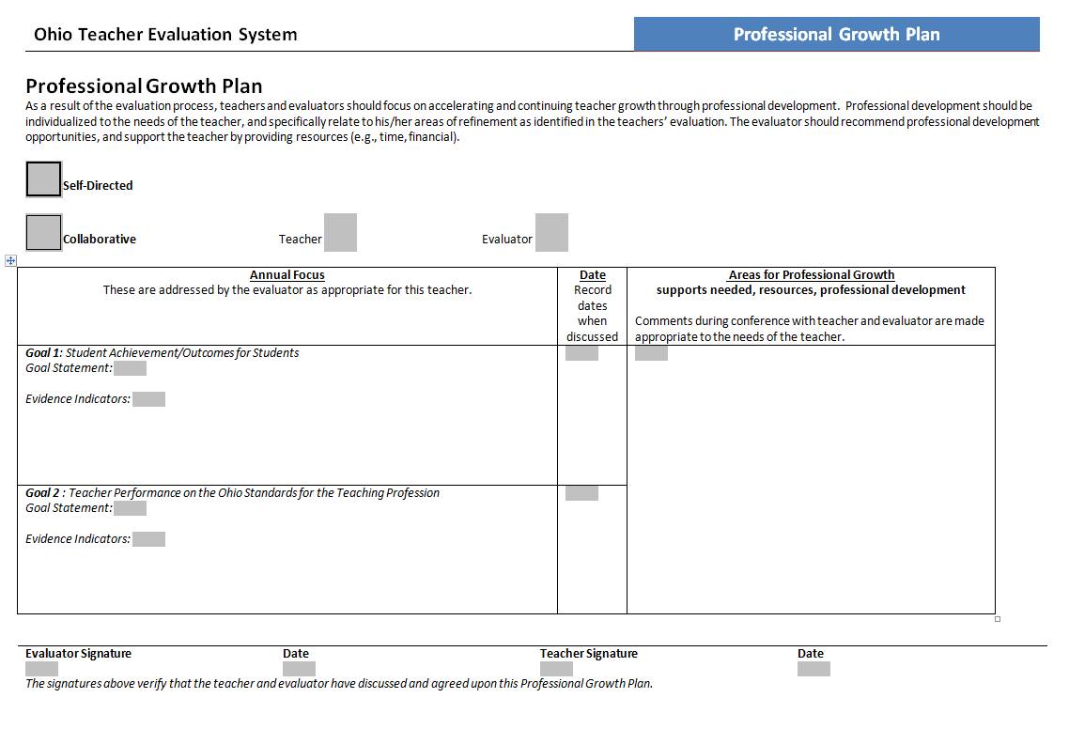

professional learning module – june 2014
For the Using ohio Teacher evaluation data to inform professional learning
Ohio Standards for Professional Development
- High quality professional development is a purposeful, structured, and continuous process that occurs over time.
- High quality professional development is informed by multiple sources of data.
- High quality professional development is collaborative.
- High quality professional development includes varied learning experiences that accommodate individual educators’ knowledge and skills.
- High quality professional development is evaluated by its short- and long-term impact on professional practice and achievement of all students.
- High quality professional development results in the acquisition, enhancement or refinement of skills and knowledge.

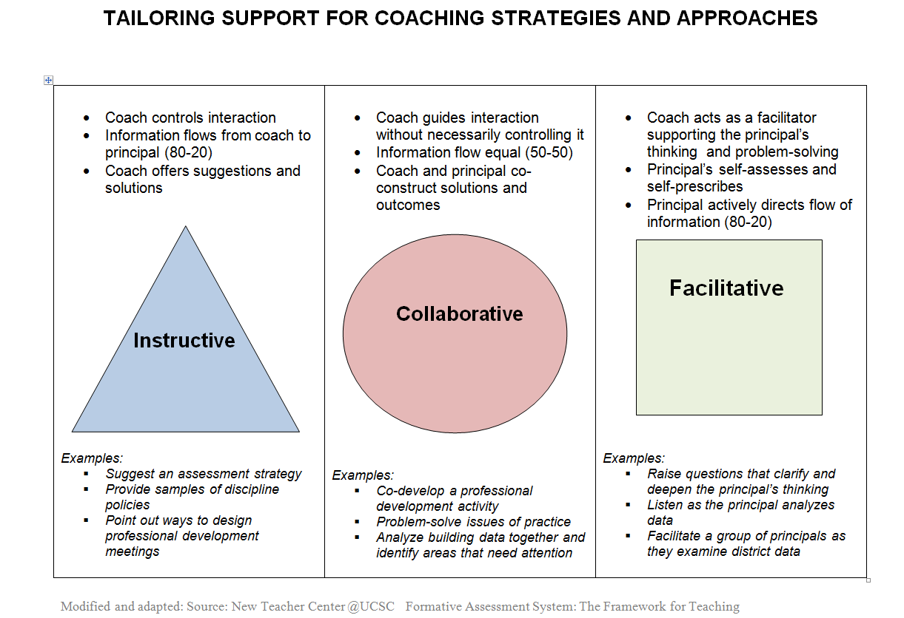

Individual Professional Learning Worksheet
Teacher Name: _______________________________________
This form is to be used to help determine professional learning for teachers based upon their performance, student growth measures, and final evaluation ratings. Using a completed OTES Evaluation Rubric for the teacher, look at each performance indicator and place the information below. Then analyze the findings to see if there are specific areas for professional learning that would benefit the teacher.
This form is not meant to be used to determine teacher evaluation ratings.

Teacher Evaluation Indicators | 2012-2013 | 2013-2014 | 2014-2015
Instructional Planning
Focus for Learning
Assessment Data
Prior Content Knowledge/Sequence/Connections
Knowledge of Students
Instruction & Assessment
Lesson Delivery
Differentiation
Resources
Classroom Environment
Assessment of Student Learning
Professionalism
Professional Responsibilities

In this section, place the appropriate information for this teacher from his/her teacher evaluation data.
Teacher Evaluation Indicators | 2012-2013 | 2013-2014 | 2014-2015
Final Performance Rating
Student Growth Measure #1
Student Growth Measure #2
Final Summative Rating

School-Level Teacher Evaluation Data to Inform Professional Learning
Teacher | Years of Experience | Performance Area of Focus 1 | Performance Area of Focus 2 | Performance  Rating | Student Growth Measure(s) Rating | Final Summative Rating
A
B
C
D
E
F
G
H
I
J
K
L
M
N
O
P
Q
R
S
T
U
V
W
X
Y
Z
Suggestion: color code and align with look-up table colors to see various patterns, trends in data

